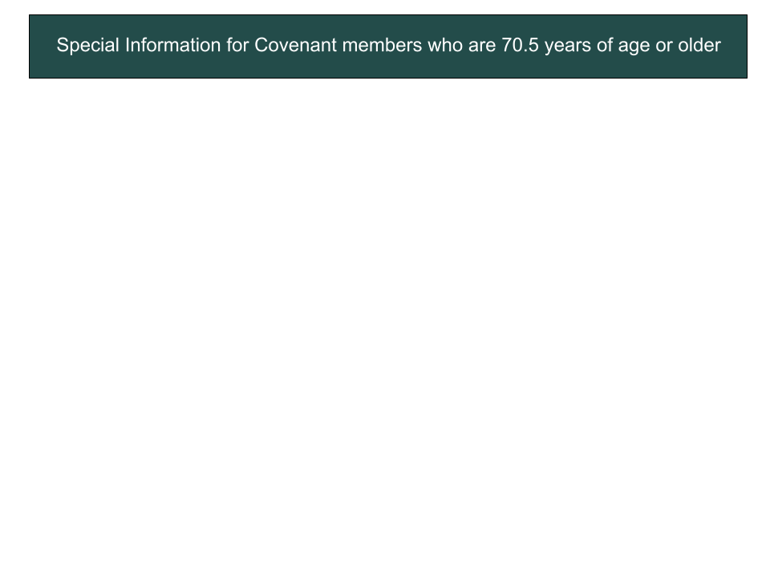
Qualified Charitable Distributions from IRAs
The “tax Cuts and Jobs Act” passed in December 2017 makes donations from IRAs directly to charity an even more powerful way to give money. Why? Because the Act nearly doubled everyone’s standard deduction beginning in 2018. The “standard deduction” is the amount all taxpayers can deduct from their taxable income instead of itemizing deductions. The percent of taxpayers itemizing deductions dropped from 30% in 2017 to approximately 10% beginning in 2018. What this means for many seniors who are 70 ½ or older is that the only way to reduce their tax bill is to make charitable donations directly from their IRA. (A direct gift from an IRA to a charity is called a “Qualified Charitable Distribution” or QCD.) And, while we don’t make gifts to reduce taxes, giving smartly enables us to give more, or have more left over.
If you are age 72 or older and have money in an IRA or other qualified retirement plan, you must withdraw a “Required Minimum Distribution” annually and the amount withdrawn is subject to tax. If you don’t withdraw your “RMD,” the IRS can assess a 50% penalty. However, you can direct your IRA custodian to pay all or a part of that required distribution (up to $100,000 annually) directly to Covenant and/or other qualified charities and avoid paying taxes on the distribution while still utilizing the increased standard deduction. These direct roll-over distributions count toward your RMD. (If your retirement funds are in another type of retirement account, such as a 401(k), you must first transfer the funds to an IRA, and that must be done prior to the year of your QCD.) So, a senior can utilize the higher standard deduction while still excluding their RMD from taxable income.
Excluding an RMD from taxable income can save taxes in other ways too. It may…
• Reduce the amount deducted from your monthly social security for Medicare,
• Reduce or eliminate the amount of tax paid on your social security income, and/or
• Reduce or eliminate the 3.8% Medicare surtax levied on other income.
And, even if itemizing deductions is still advantageous, subtracting an RMD from one’s income may...
• Increase deductions for medical expenses, and/or
• Avoid the annual limit on deductible charitable donations.
Whether or not these tax savings are available to you depends on your individual tax situation, but there are few instances in which this way of donating does not save more tax. Please seek specific advice from your financial, tax and/or legal advisors to determine if this way of donating benefits you.
Legacy Giving
For many, the best way to leave a legacy gift to Covenant United Methodist’s Endowment or other charity is from their IRA and/or other tax-deferred account. With estate tax exemptions in excess of $11.5 million for singles and $23 million for married couples, most estates will not pay estate tax. The tax basis of most estate assets (such as real estate, appreciated stocks and mutual funds) will be adjusted to their fair market value as of the date of death. The exceptions to this rule are IRAs and other tax-deferred accounts. The income tax on these tax-deferred assets does not go away at death but remains as a tax liability to the recipient, unless the recipient is a qualified charity such as the Covenant Endowment. So, if you are planning a legacy gift, it should first come from your IRA or other tax-deferred accounts, leaving the “tax-free assets” to your beneficiaries who are individuals. Please feel free to contact us if you have questions about a QCD to our Church or a legacy gift to our Foundation. We have volunteers who can assist you in determining how to give more to charity and your individual beneficiaries, and less to taxes.
For additional information, contact:
Ashley Beebee, CUMC Edowment Chairperson
abeebee@icloud.com | 512.917.5590
Covenant United Methodist Church has a form to use for your “Request for Charitable Distribution from Individual Retirement Account.” Please contact Ashley Beebee, and she will provide you with the form.

