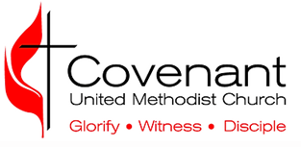

Request for Qualified Charitable Distribution from my IRA to Covenant United Methodist Church
Re: Request for Charitable Distribution from Individual Retirement Account
Dear IRA Custodian:
Please accept this letter as my request to make a direct Qualified Charitable Distribution from my Individual Retirement Account (Account Number____________________ ) as provided by IRC Section 408(d)(8) as amended.
Please issue a check in the amount of $ ________________ payable to: Covenant United Methodist Church, FEIN 585869-1
Mail the check to: Covenant United Methodist Church, Attn: Finance 4410 Duval Road, Austin, TX 78727
Contact covenantumc@covenantaustin.org with questions or requests for assistance.
Please designate my gift as follows:
- Ministry Fund for (year) ______________ (amount) $_______________
- Covenant Food Pantry
- Children/Youth
- Debt Service
- Building (Trustees)
In your transmittal of funds to Covenant, please note my name and address as the donor of record in connection with this transfer and transmit a copy of this request form with the payment of my distribution. Please copy me on your transmittal.
If you have any questions or need to contact me, my contact information is:
Name of plan owner _____________________________________________________________
Address _______________________________________________________________________
Telephone ________________________ Email ________________________________________
Signature of Plan Owner ________________________________________ Date _____________

